PIZZA SALES SQL QUERIES
KPI Queries and results
--1. Total Revenue

SELECT ROUND(SUM(total_price) ,2) AS Total_Revenue
FROM pizza_sales
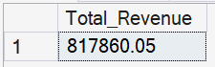

--2. Average Order Value

SELECT ROUND(SUM(total_price)/COUNT (DISTINCT order_id),2) AS Average_Order_Value
FROM pizza_sales
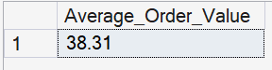
--3. Total Pizzas Sold

SELECT SUM(quantity) AS Total_Pizzas_Sold
FROM pizza_sales

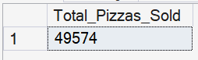

--4. Total Orders Placed

SELECT COUNT(DISTINCT order_id) AS total_orders_placed
FROM pizza_sales

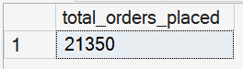

--5. Average pizza per order

SELECT CAST(CAST(SUM(quantity) AS DECIMAL(10,2))/CAST(COUNT(DISTINCT order_id) AS DECIMAL(10,2)) AS DECIMAL(10,2)) AS Average_pizza_per_order
FROM pizza_sales
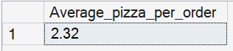

Trend Analysis/Charts

--6. Daily trend for orders

SELECT DATENAME(WEEKDAY,order_date) as day_name, COUNT(DISTINCT order_id) AS order_count
FROM pizza_sales
GROUP BY DATENAME(WEEKDAY, order_date)

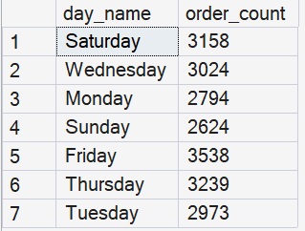

--7. Monthly trend for total orders

SELECT DATENAME(MONTH,order_date) as month_name, COUNT(DISTINCT order_id) AS total_orders
FROM pizza_sales
GROUP BY DATENAME(MONTH, order_date)
ORDER BY total_orders DESC

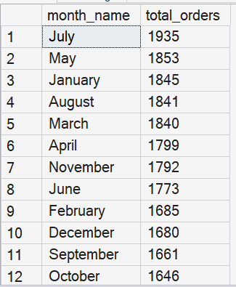

--8. % of sales by pizza category

SELECT pizza_category, CAST(SUM(total_price) AS DECIMAL(10,2)) AS total_sales , CAST(SUM(total_price)*100/(SELECT SUM(total_price) FROM pizza_sales) AS DECIMAL(10,2)) as pct_total_sales
FROM pizza_sales
GROUP BY pizza_category

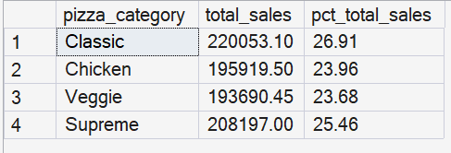

--9. % of sales by pizza size

SELECT pizza_size, CAST(SUM(total_price) AS DECIMAL(10,2)) AS total_sales , CAST(SUM(total_price)*100/(SELECT SUM(total_price) FROM pizza_sales) AS DECIMAL(10,2)) as pct_total_sales
FROM pizza_sales
GROUP BY pizza_size
ORDER BY pct_total_sales DESC

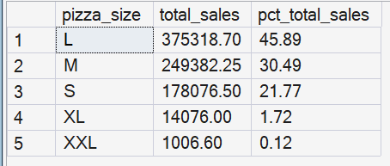

--10. Top 5 best sellers by total revenue

SELECT TOP 5 WITH TIES pizza_name, CAST(SUM(total_price) AS DECIMAL(10,2)) as total_revenue
FROM pizza_sales
GROUP BY pizza_name
ORDER BY total_revenue DESC

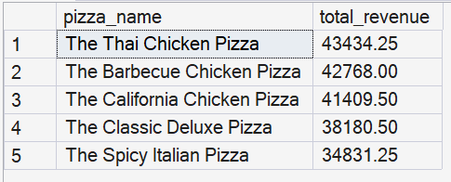

--11. Top 5 best sellers by total quantity

SELECT TOP 5 WITH TIES pizza_name, SUM(quantity) as total_quantity
FROM pizza_sales
GROUP BY pizza_name
ORDER BY total_quantity DESC

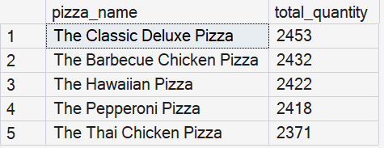

--12. Top 5 best sellers by total orders

SELECT TOP 5 WITH TIES pizza_name, COUNT(DISTINCT order_id) as total_orders
FROM pizza_sales
GROUP BY pizza_name
ORDER BY total_orders DESC

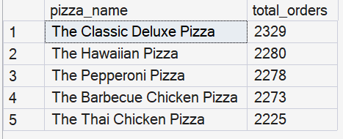

--13. Bottom 5 sellers by total revenue

SELECT TOP 5 WITH TIES pizza_name, CAST(SUM(total_price) AS DECIMAL(10,2)) as total_revenue
FROM pizza_sales
GROUP BY pizza_name
ORDER BY total_revenue

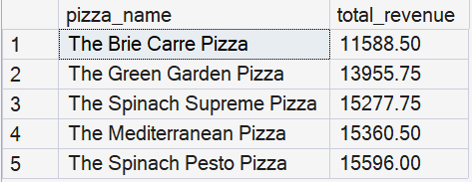

--14. Bottom 5 sellers by total quantity

SELECT TOP 5 WITH TIES pizza_name, SUM(quantity) as total_quantity
FROM pizza_sales
GROUP BY pizza_name
ORDER BY total_quantity

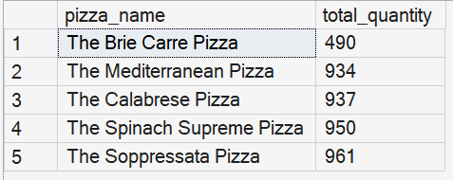

--15. Bottom 5 sellers by total orders

SELECT TOP 5 WITH TIES pizza_name, COUNT(DISTINCT order_id) as total_orders
FROM pizza_sales
GROUP BY pizza_name
ORDER BY total_orders

